Notes : Deep Learning with Python

In 1843, Ada Lovelace remarked on the invention, “The Analytical Engine has no pretensions whatever to originate anything. It can do whatever we know how to order it to perform.… Its province is to assist us in making available what we’re already acquainted with.”

“Lady Lovelace’s objection”

**Machine learning**

Machine learning arises from this question: could a computer go beyond “what we know how to order it to perform” and learn on its own how to perform a specified task? Could a computer surprise us? Rather than programmers crafting data-processing rules by hand, could a computer automatically learn these rules by looking at data?

This question opens the door to a new programming paradigm. In classical programming, the paradigm of symbolic AI, humans input rules (a program) and data to be processed according to these rules, and out come answers (see figure 1.2). With machine learning, humans input data as well as the answers expected from the data, and out come the rules. These rules can then be applied to new data to produce original answers.

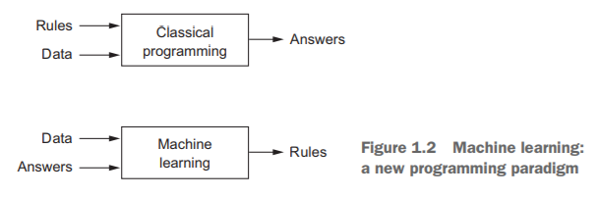

**Learning representations from data**

machine learning discovers rules to execute a data-processing task, given examples of what’s expected. So, to do machine learning, we need three things:

1. Input data points—For instance, if the task is speech recognition, these data points could be sound files of people speaking. If the task is image tagging, they could be pictures.

2. Examples of the expected output—In a speech-recognition task, these could be human-generated transcripts of sound files. In an image task, expected outputs could be tags such as “dog,” “cat,” and so on.

3. A way to measure whether the algorithm is doing a good job—This is necessary in order to determine the distance between the algorithm’s current output and its expected output. The measurement is used as a feedback signal to adjust the way the algorithm works. This adjustment step is what we call learning.

systematically searching for different possible coordinate changes, and used as feedback the percentage of points being correctly classified, then we would be doing machine learning. Learning, in the context of machine learning, describes an automatic search process for better representations.

Machine-learning algorithms aren’t usually creative in finding these transformations; they’re merely searching through a predefined set of operations, called a hypothesis space.

A machine-learning model transforms its input data into meaningful outputs, a process that is “learned” from exposure to known examples of inputs and outputs. Therefore, the central problem in machine learning and deep learning is to meaningfully transform data: in other words, to learn useful representations of the input data at hand—representations that get us closer to the expected output.

Machine-learning models are all about finding appropriate representations for their input data—transformations of the data that make it more amenable to the task at hand, such as a classification task.

**The “deep” in deep learning**

Deep learning is a specific subfield of machine learning: a new take on learning representations from data that puts an emphasis on learning successive layers of increasingly meaningful representations. How many layers contribute to a model of the data is called the depth of the model. In deep learning, these layered representations are (almost always) learned via models called neural networks, structured in literal layers stacked on top of each other.

**How deep learning works**

The specification of what a layer does to its input data is stored in the layer’s weights, which in essence are a bunch of numbers. In technical terms, we’d say that the transformation implemented by a layer is parameterized by its weights (see figure 1.7). (Weights are also sometimes called the parameters of a layer.) In this context, learning means finding a set of values for the weights of all layers in a network, such that the network will correctly map example inputs to their associated targets.

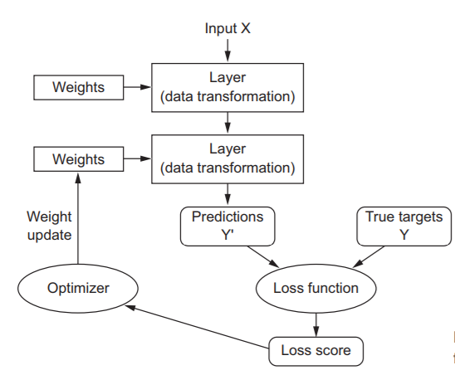

To control something, first you need to be able to observe it. To control the output of a neural network, you need to be able to measure how far this output is from what you expected. This is the job of the loss function of the network, also called the objective function. The loss function takes the

predictions of the network and the true target (what you wanted the network to output) and computes a distance score, capturing how well the network has done

The fundamental trick in deep learning is to use this score as a feedback signal to adjust the value of the weights a little, in a direction that will lower the loss score

This adjustment is the job of the optimizer, which implements what’s called the Backpropagation algorithm: the central algorithm in deep learning.

Initially, the weights of the network are assigned random values, so the network merely implements a series of random transformations. Naturally, its output is far from what it should ideally be, and the loss score is accordingly very high. But with every example the network processes, the weights are adjusted a little in the correct direction, and the loss score decreases. This is the training loop, which, repeated a sufficient number of times (typically tens of iterations over thousands of examples), yields weight values that minimize the loss function. A network with a minimal loss is one for which the outputs are as close as they can be to the targets: a trained network.

**Classical Machine Learning**

**Probabilistic Modeling**

Naïve Bays’ theorem while assuming that the features in the input data are all independent (a strong, or “naive” assumption, which is where the name comes from). A closely related model is the logistic regression (logreg for short), which is sometimes considered to be the “hello world” of modern machine learning. Don’t be misled by its name—logreg is a classification algorithm rather than a regression algorithm.

**Early Neural Networks**

The first successful practical application of neural nets came in 1989 from Bell Labs, when Yann LeCun combined the earlier ideas of convolutional neural networks and backpropagation, and applied them to the problem of classifying handwritten digits. The resulting network, dubbed LeNet, was used by the United States Postal Service in the 1990s to automate the reading of ZIP codes on mail envelopes.

**Kernel Methods**

Kernel methods are a group of classification algorithms, the best known of which is the support vector machine (SVM).

SVMs aim at solving classification problems by finding good decision boundaries (see figure 1.10) between two sets of points belonging to two different categories. A decision boundary can be thought of as a line or surface separating your training data into two spaces corresponding to two categories. To classify new data points, you just need to check which side of the decision boundary they fall on.

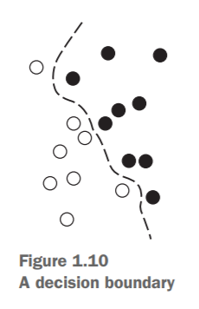

SVMs proceed to find these boundaries in two steps:

1. The data is mapped to a new high-dimensional representation where the decision boundary can be expressed as a hyperplane (if the data was two dimensional, as in figure 1.10, a hyperplane would be a straight line).
2. A good decision boundary (a separation hyperplane) is computed by trying to maximize the distance between the hyperplane and the closest data points from each class, a step called maximizing the margin. This allows the boundary to generalize well to new samples outside of the training dataset.

you just need to compute the distance between pairs of points in that space, which can be done efficiently using a kernel function. A kernel function is a computationally tractable operation that maps any two points in your initial space to the distance between these points in your target representation space, completely bypassing the explicit computation of the new representation… But SVMs proved hard to scale to large datasets and didn’t provide good results for perceptual problems such as image classification. Because an SVM is a shallow method, applying an SVM to perceptual problems requires first extracting useful representations manually (a step called feature engineering), which is difficult and brittle.

**Decision trees, random forests, and gradient boosting machines**

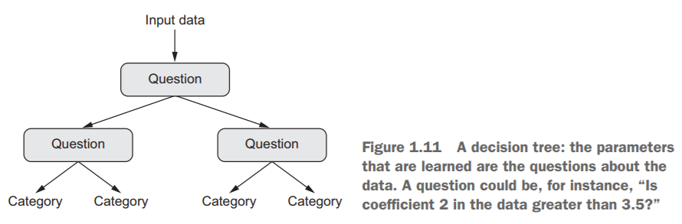

Decision trees are flowchart-like structures that let you classify input data points or predict output values given inputs (see figure 1.11). They’re easy to visualize and interpret

In particular, the Random Forest algorithm introduced a robust, practical take on decision-tree learning that involves building a large number of specialized decision trees and then ensembling their outputs. Random forests are applicable to a wide range of problems—you could say that they’re almost always the second-best algorithm for any shallow machine-learning task… until 2014, when gradient boosting machines took over. A gradient boosting machine, much like a random forest, is a machine-learning technique based on ensembling weak prediction models, generally decision trees. uses gradient boosting, a way to improve any machine-learning model by iteratively training new models that specialize in addressing the weak points of the previous models. Applied to decision trees, the use of the gradient boosting technique results in models that strictly outperform random forests most of the time, while having similar properties. It may be one of the best, if not the best, algorithm for dealing with nonperceptual data today. Alongside deep learning, it’s one of the most commonly used techniques in Kaggle competitions.

Course 1

Week 1

Neuro – ReLU – Rectified Linear Unit

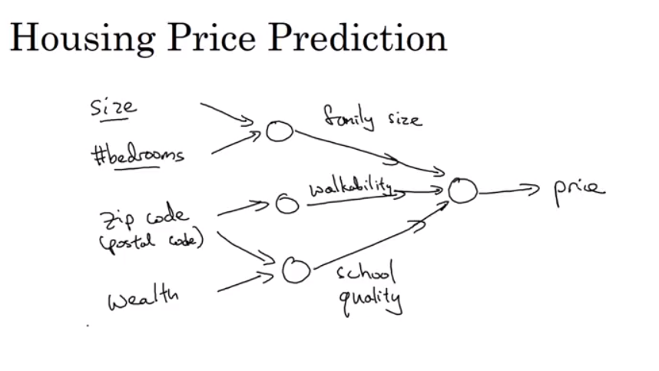

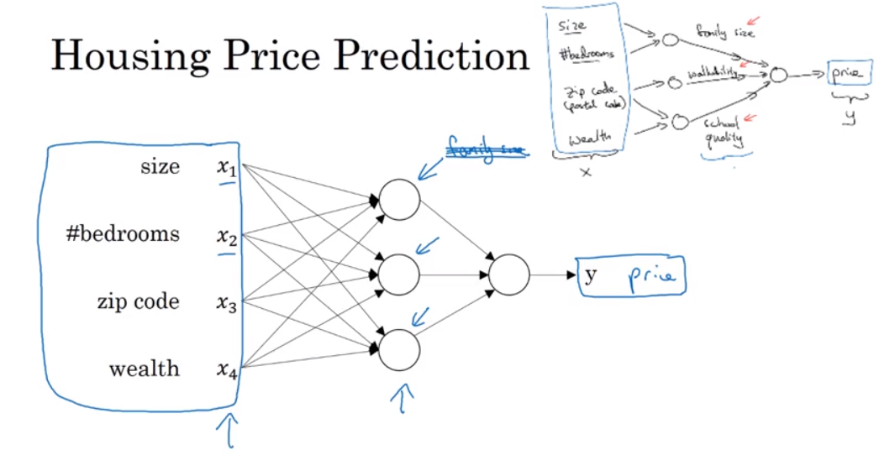

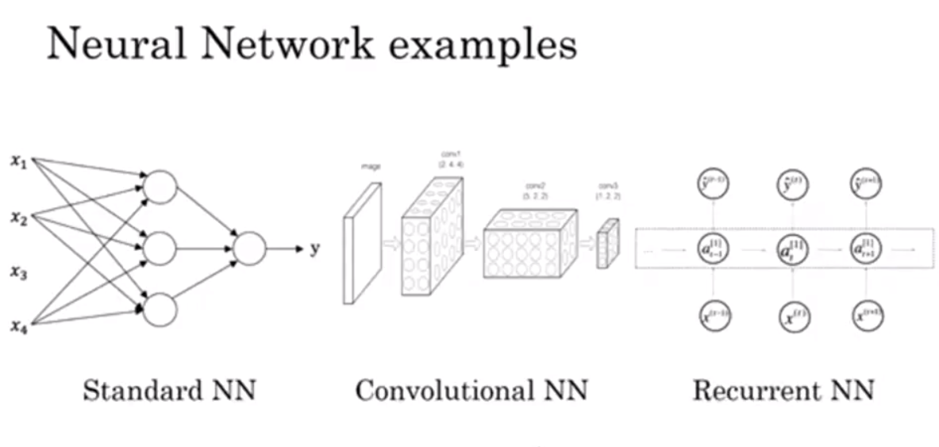

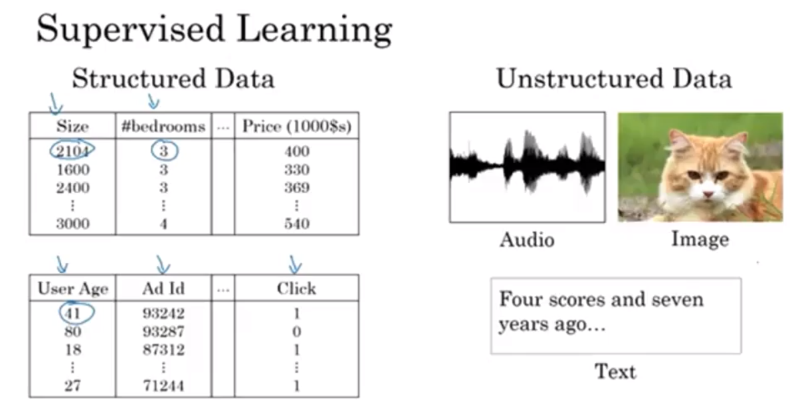

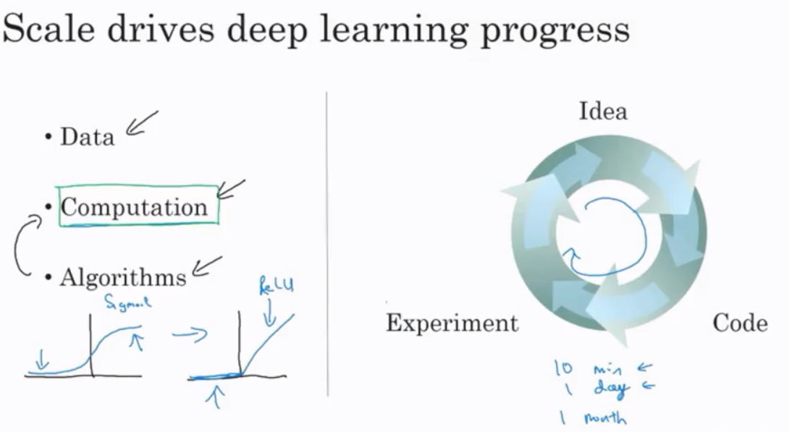

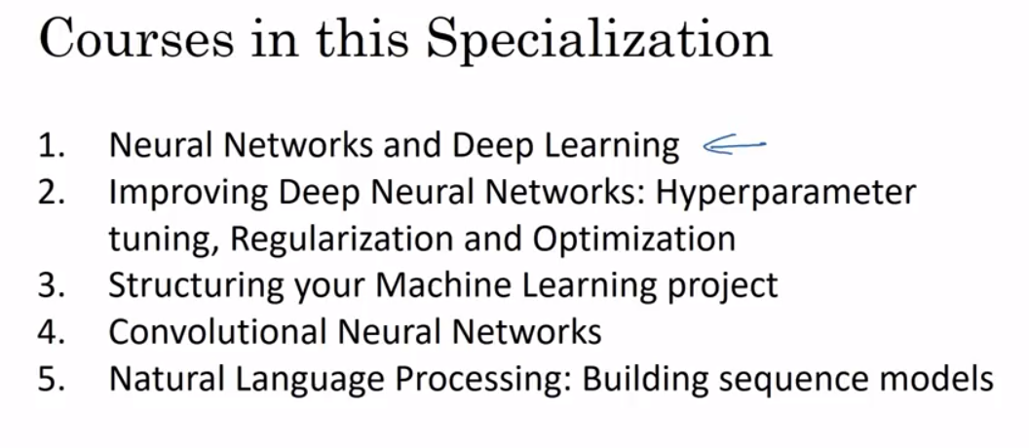

Week 2

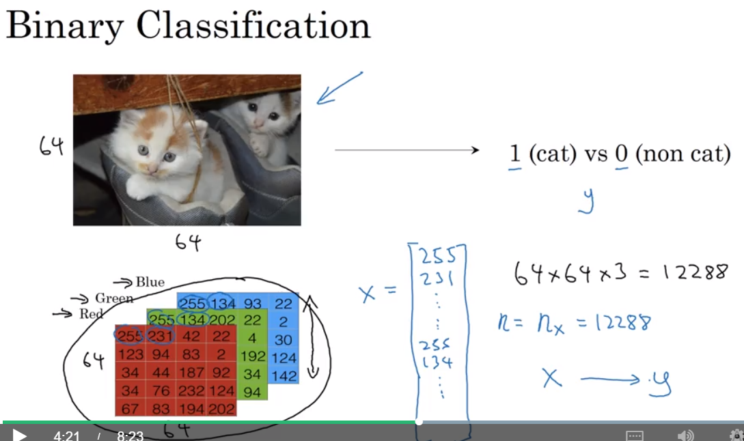

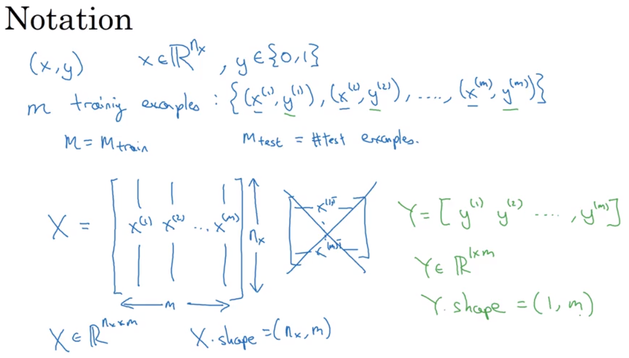

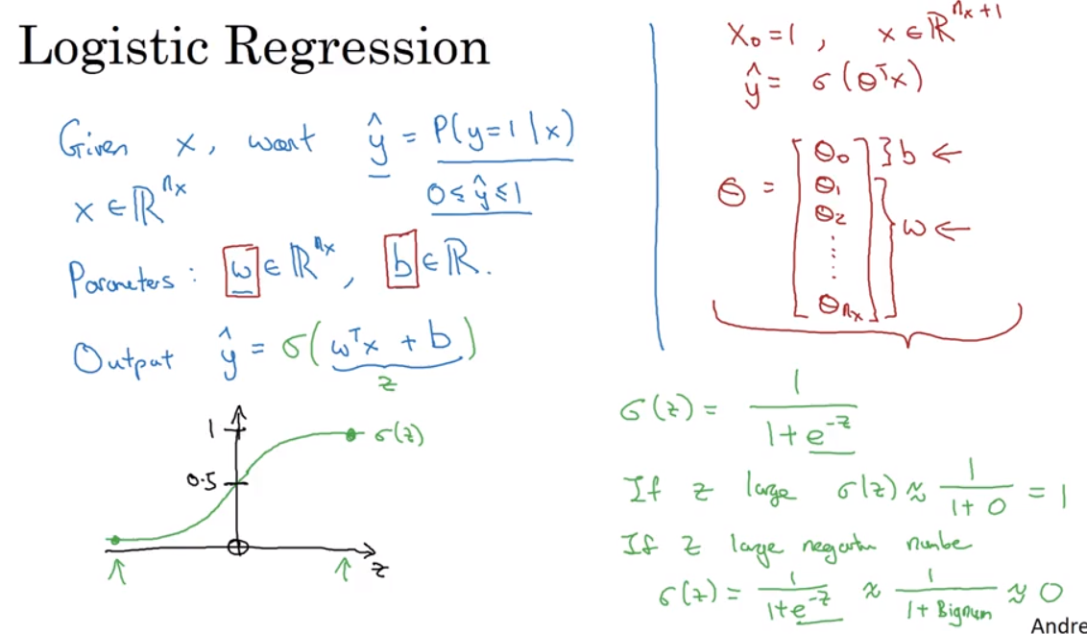

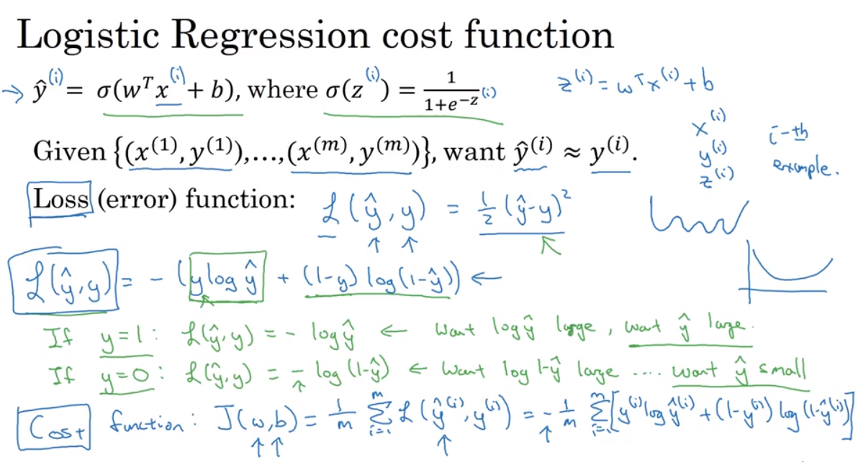

Loss function for a single training set whereas Cost function for an entire training set

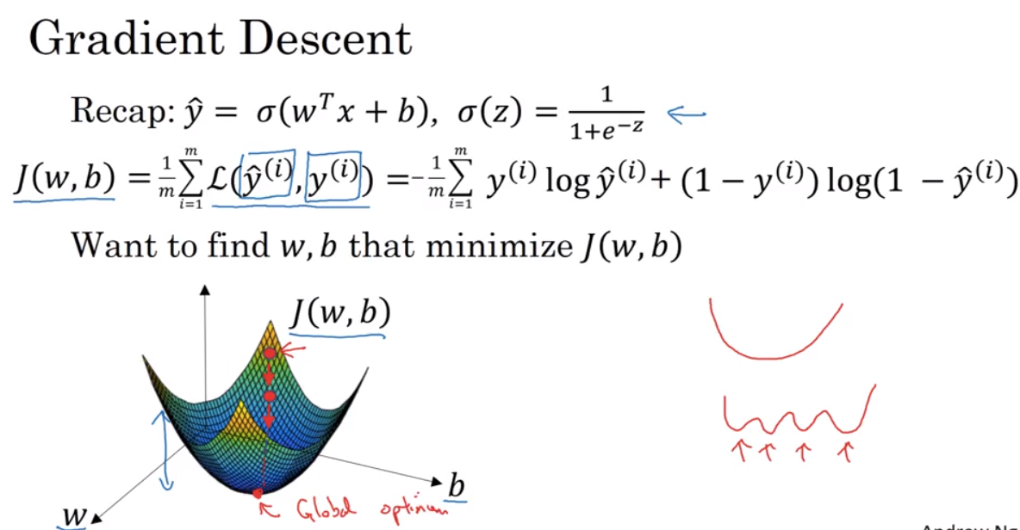

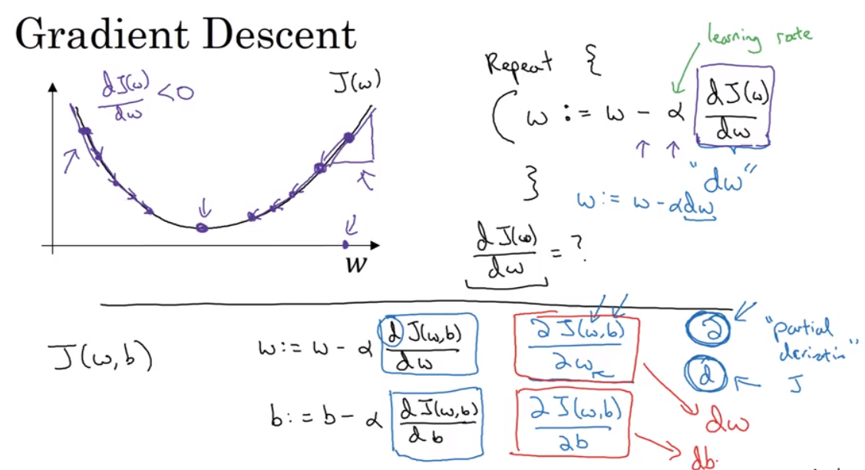

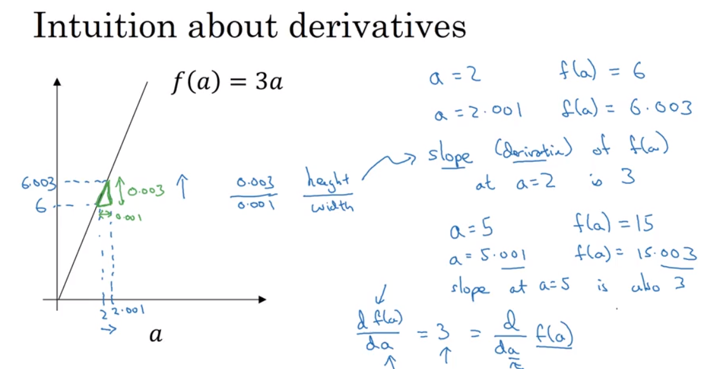

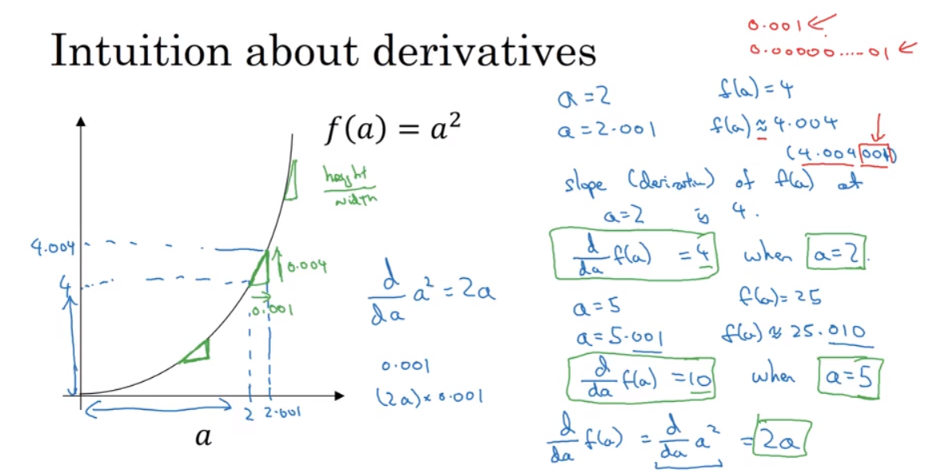

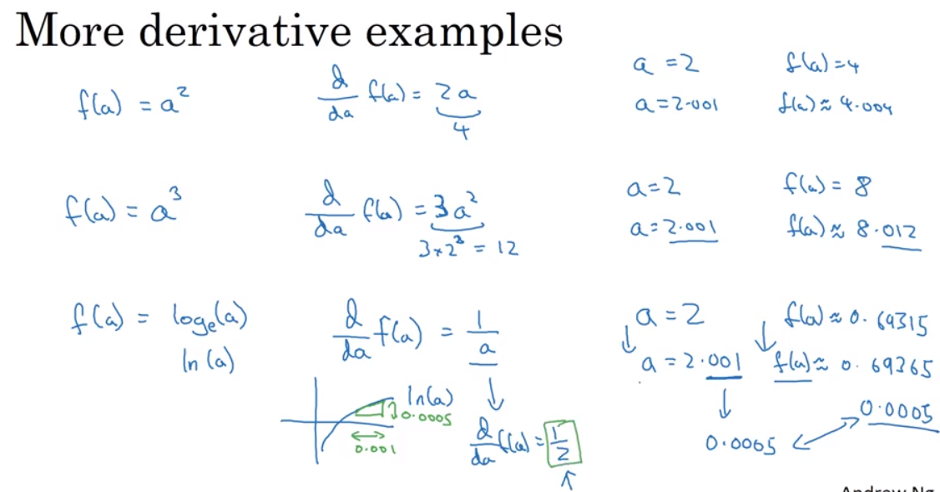

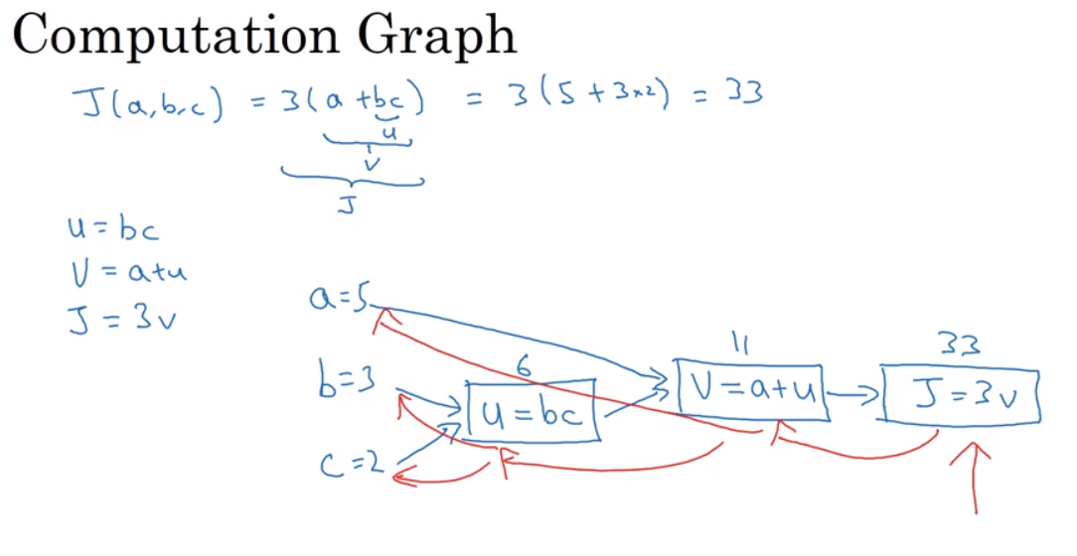

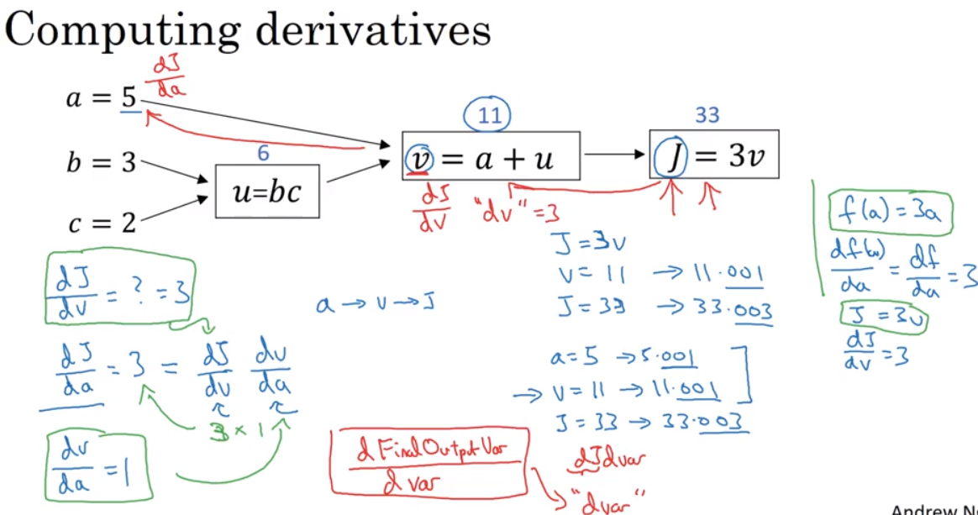

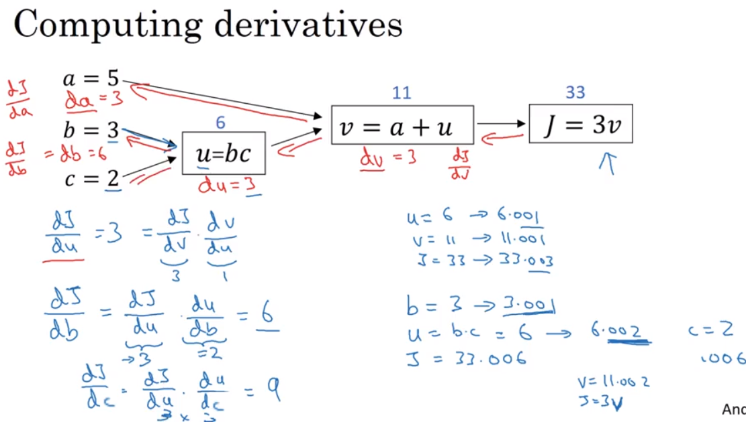

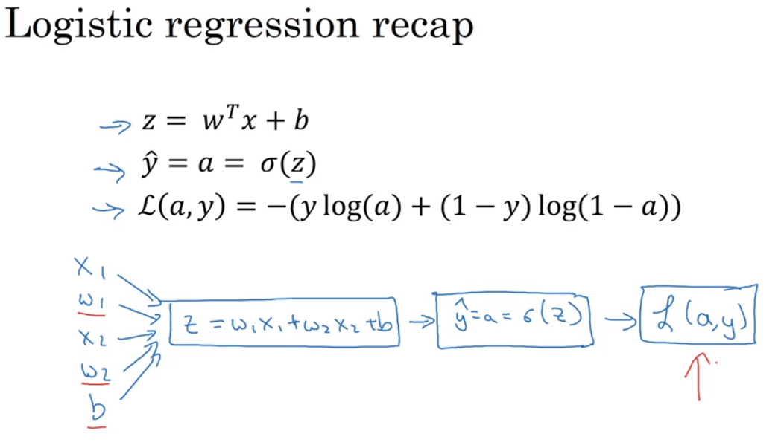

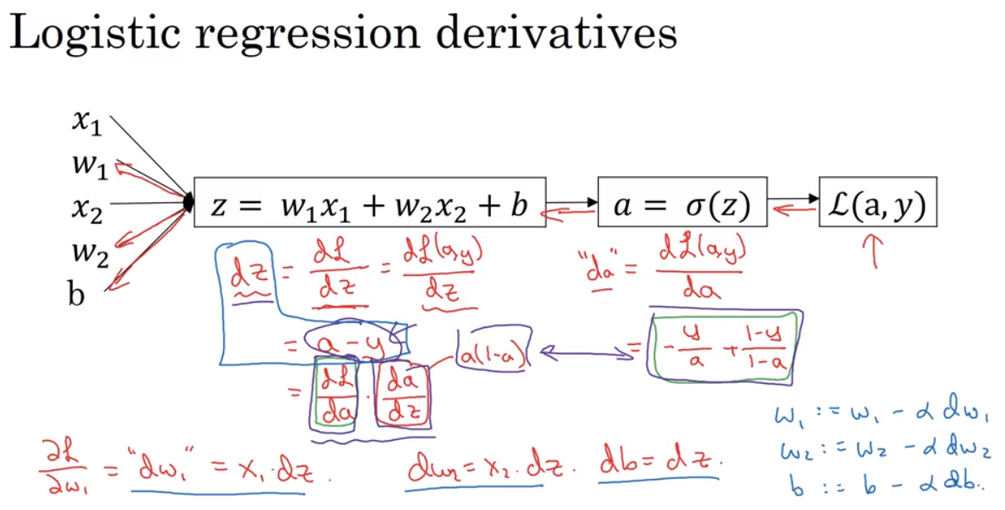

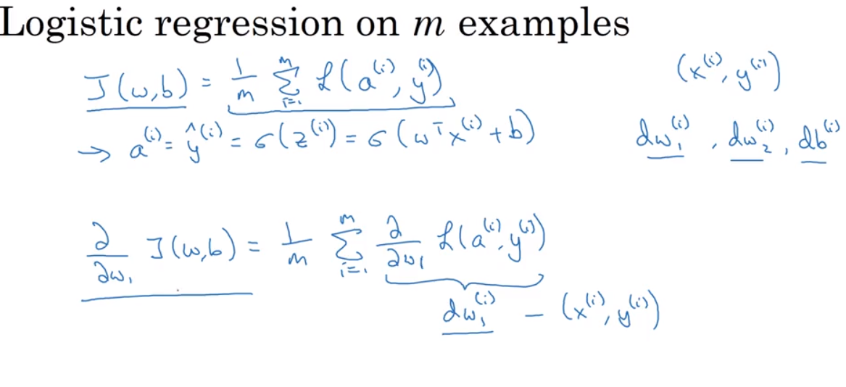

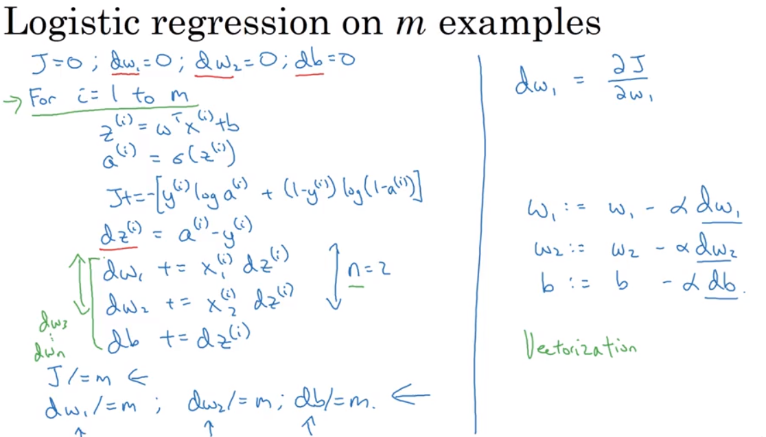

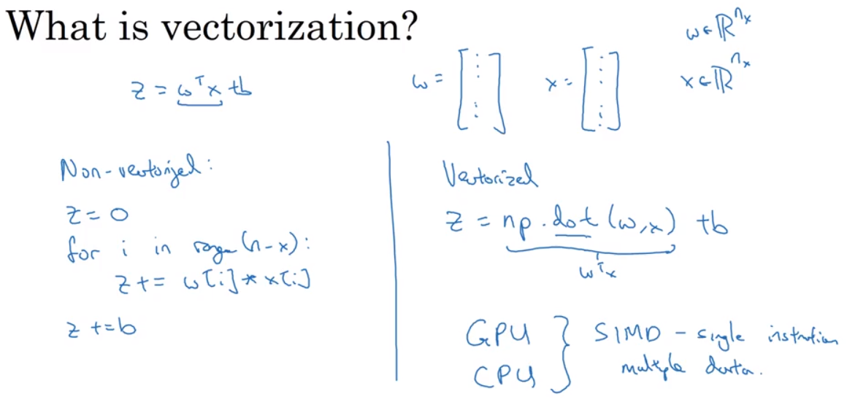

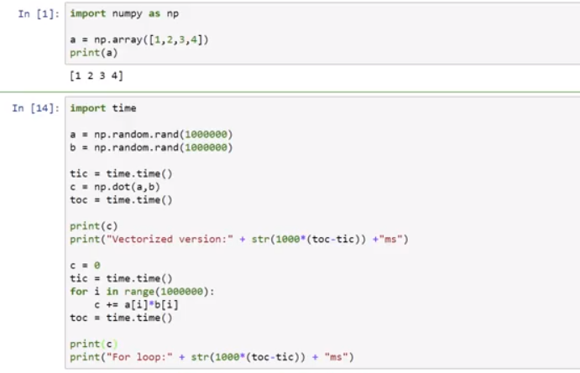

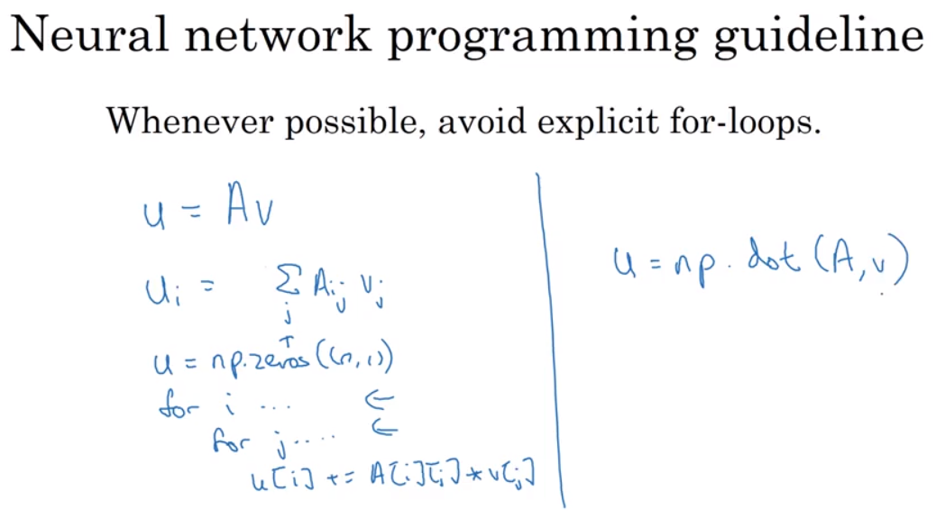

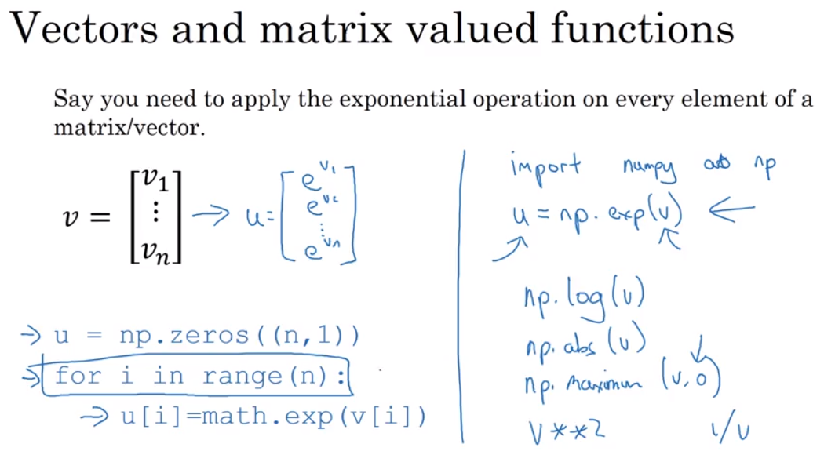

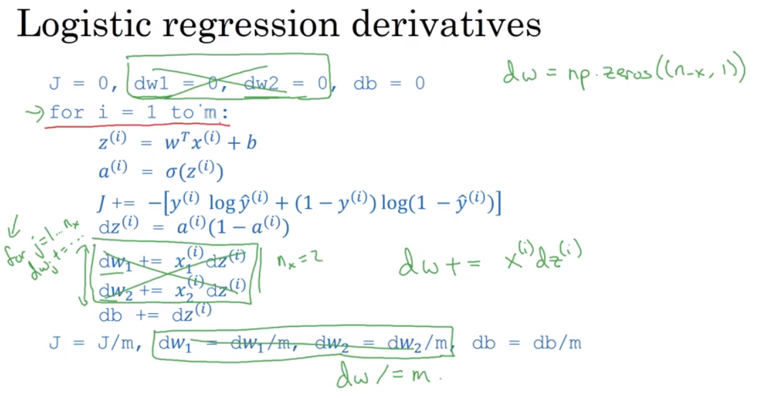

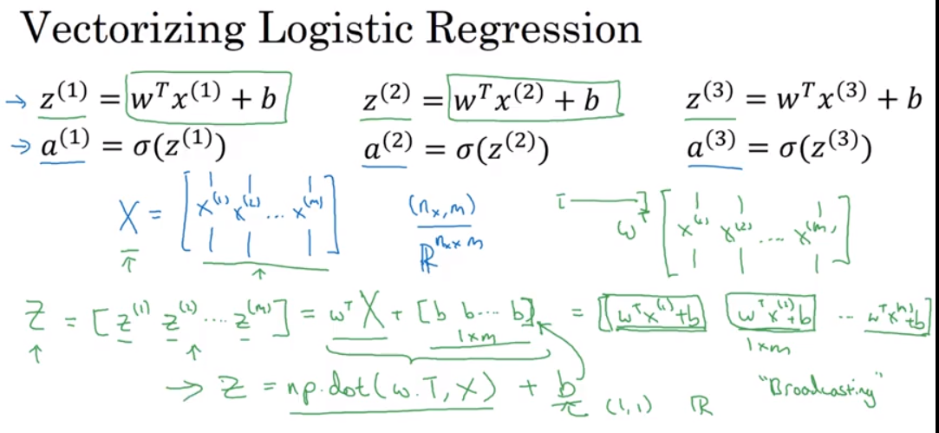

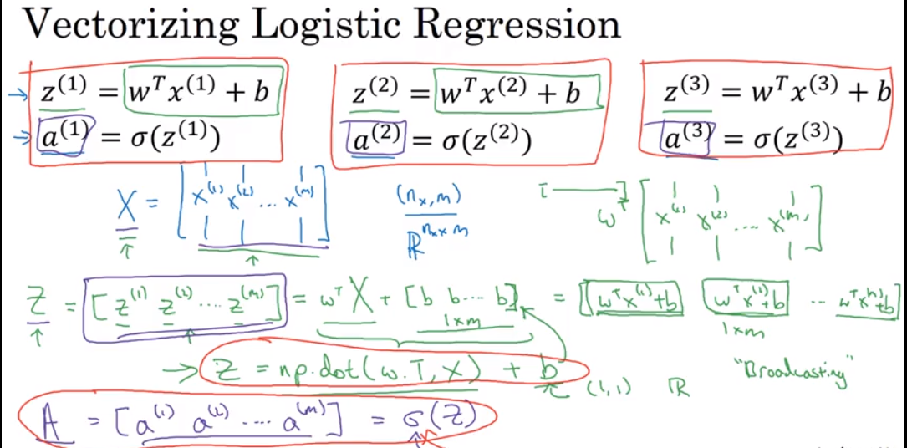

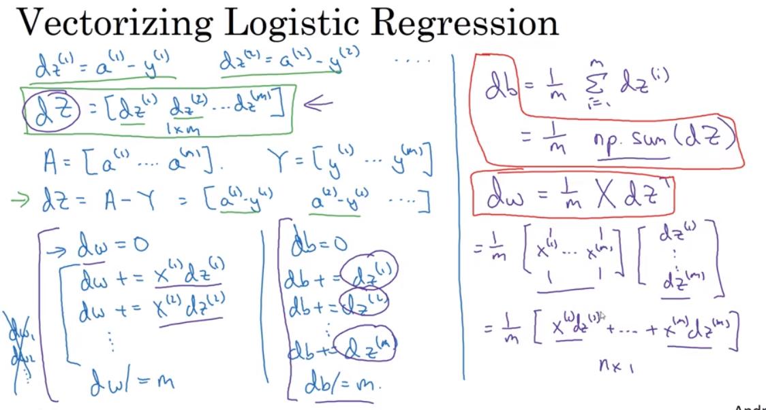

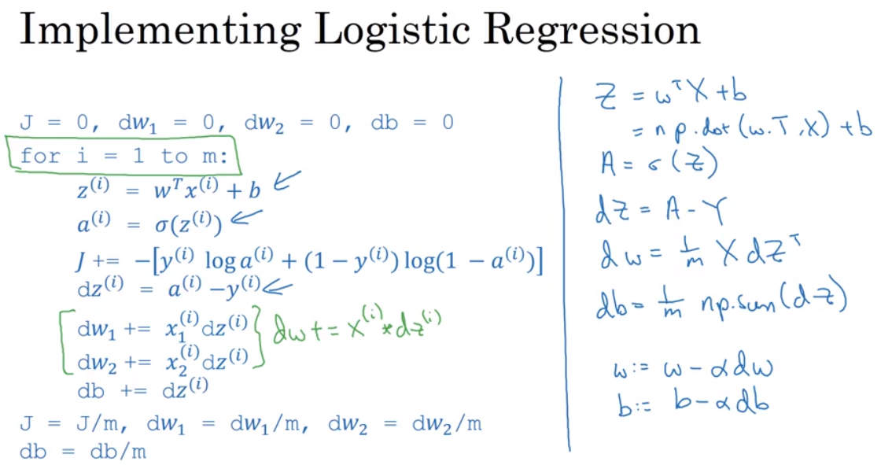

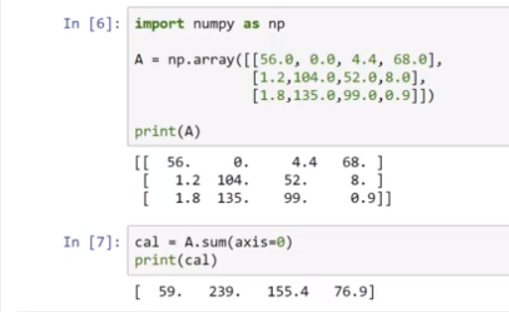

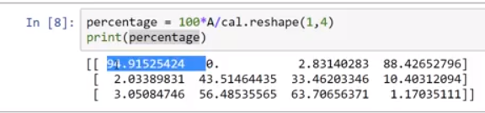

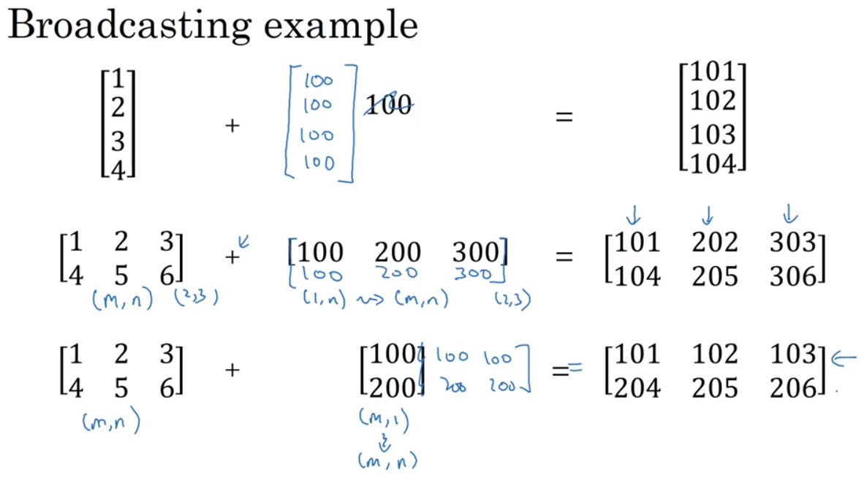

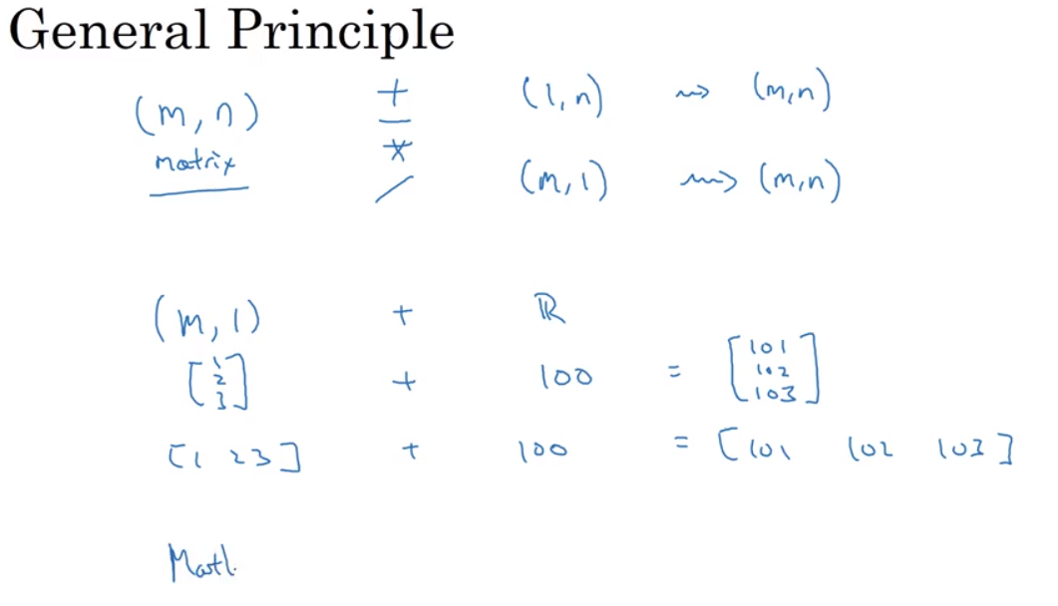

More general broadcasting rule, read numpy in python

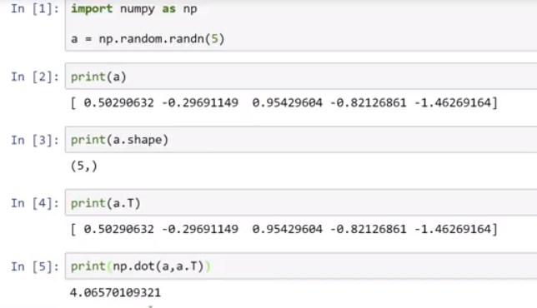

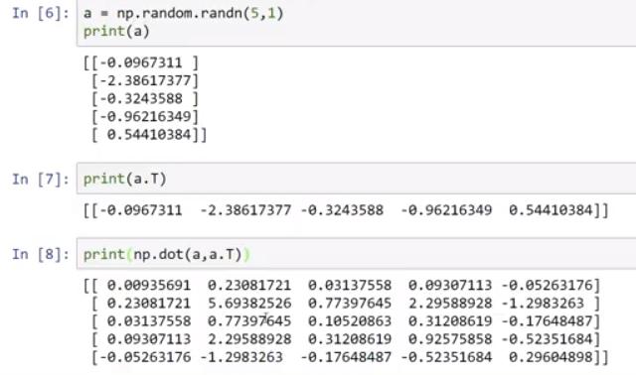

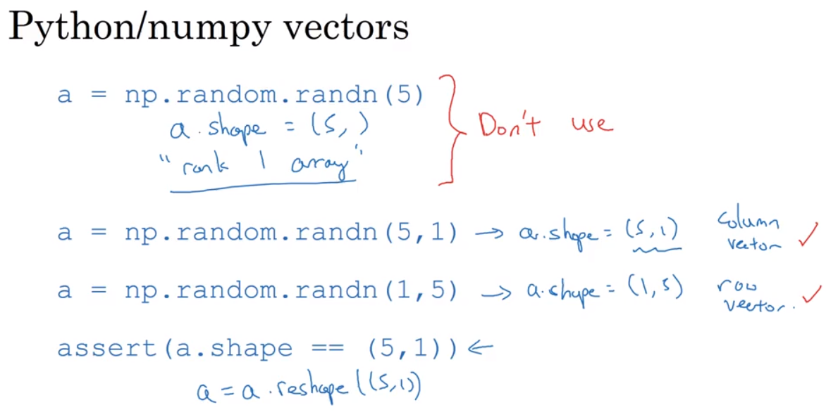

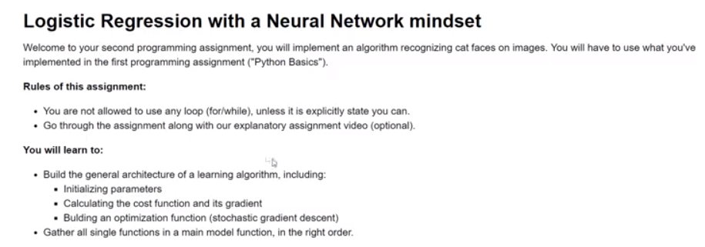

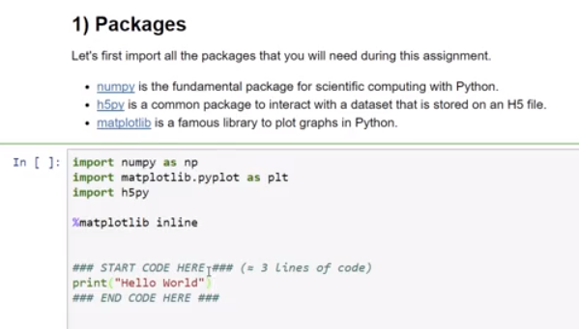

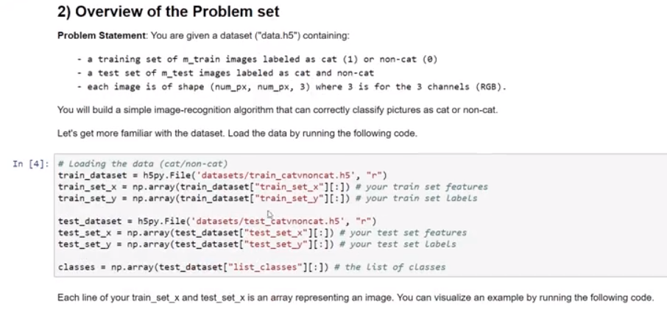

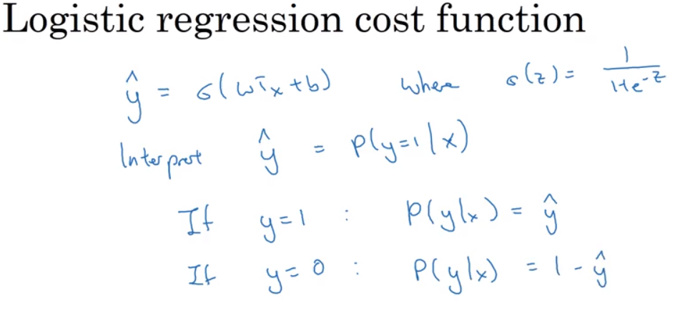

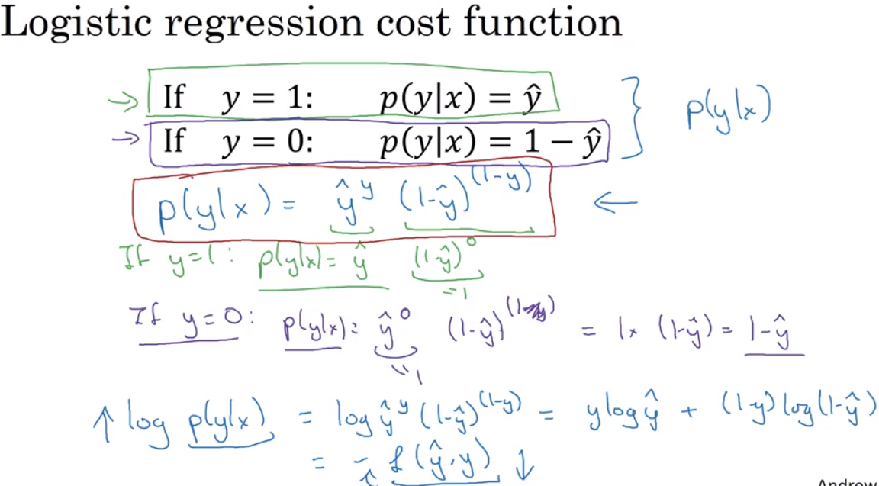

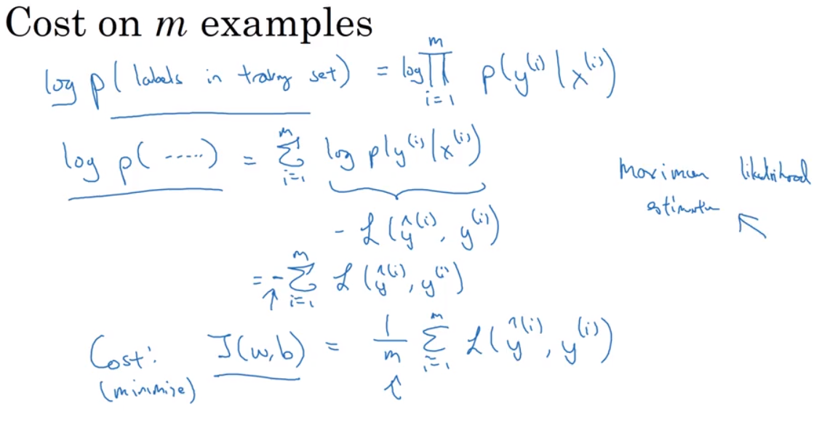

Week 3

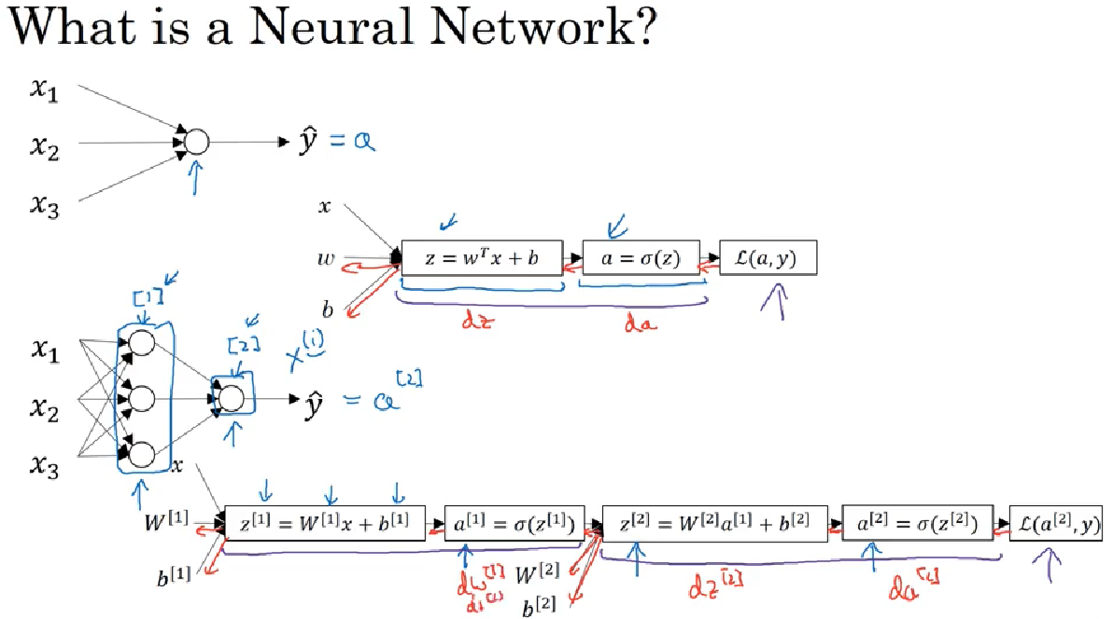

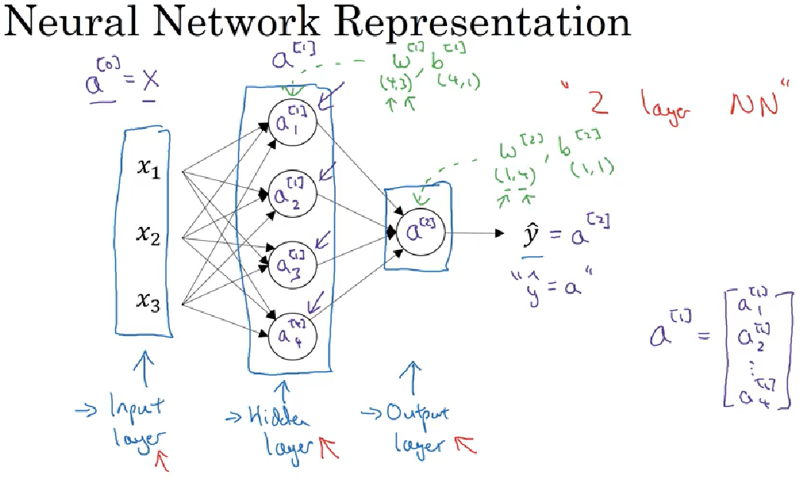

Input layer is 0, hiden is 1 and final Is 2 => called 2NN

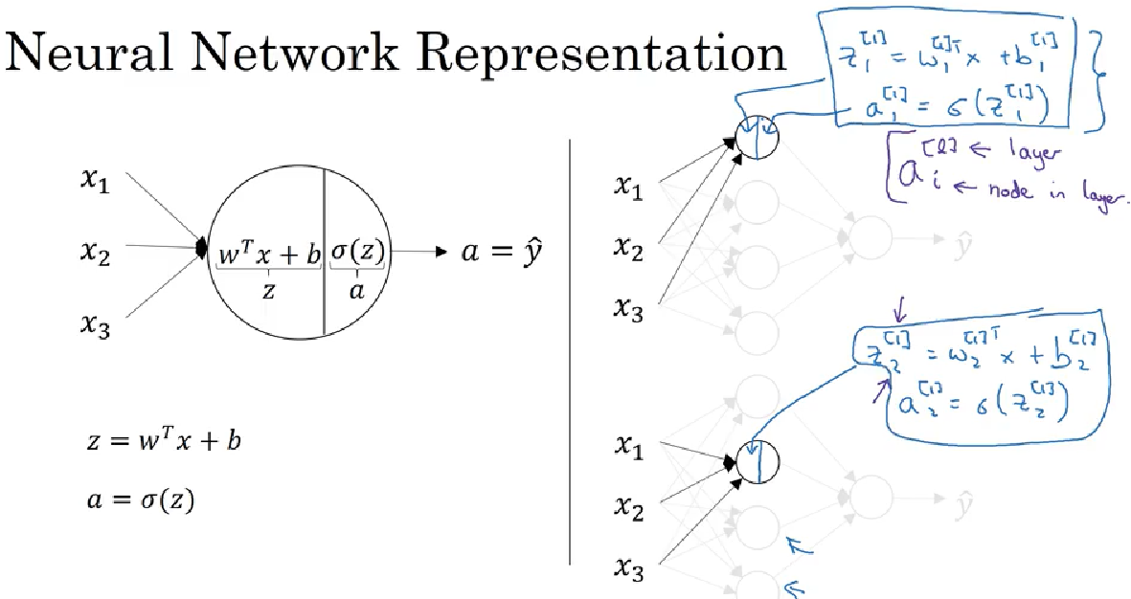

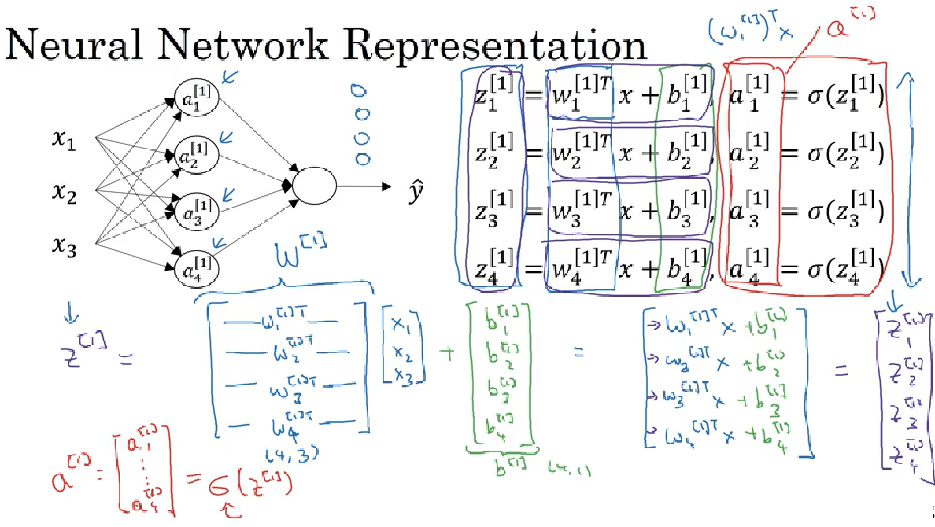

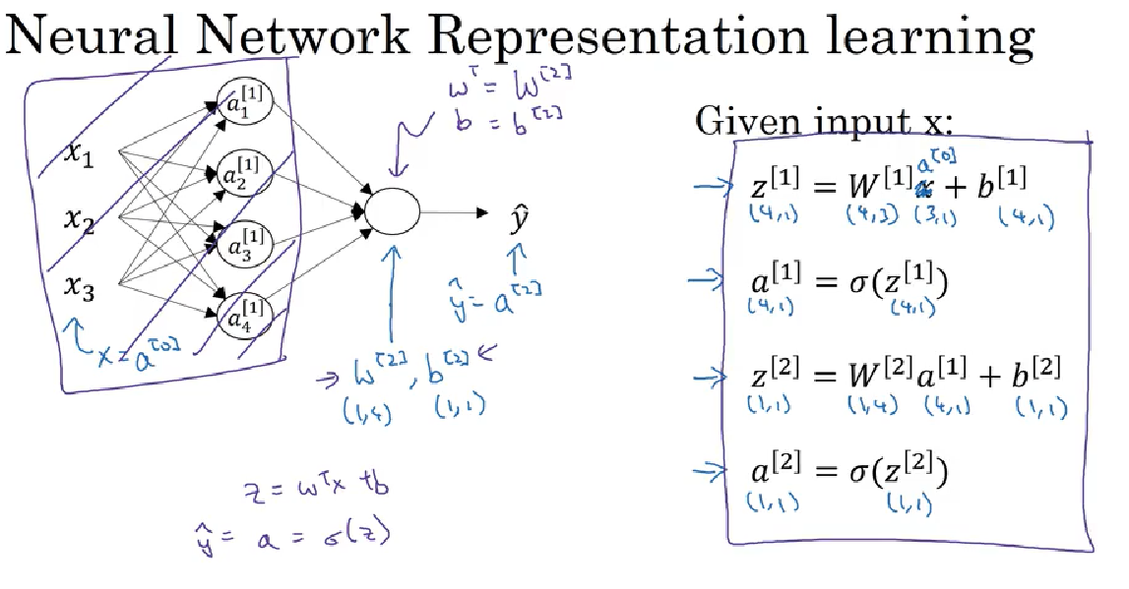

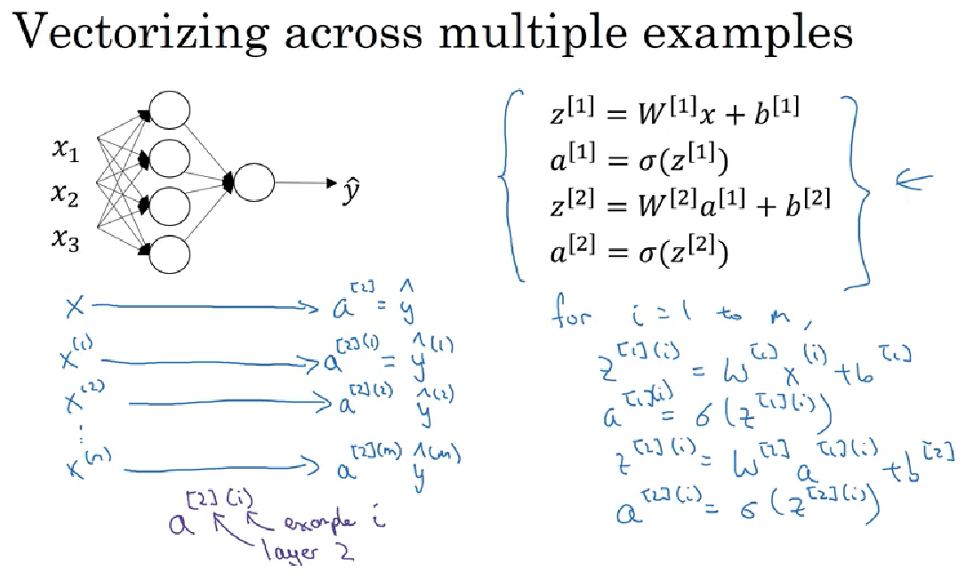

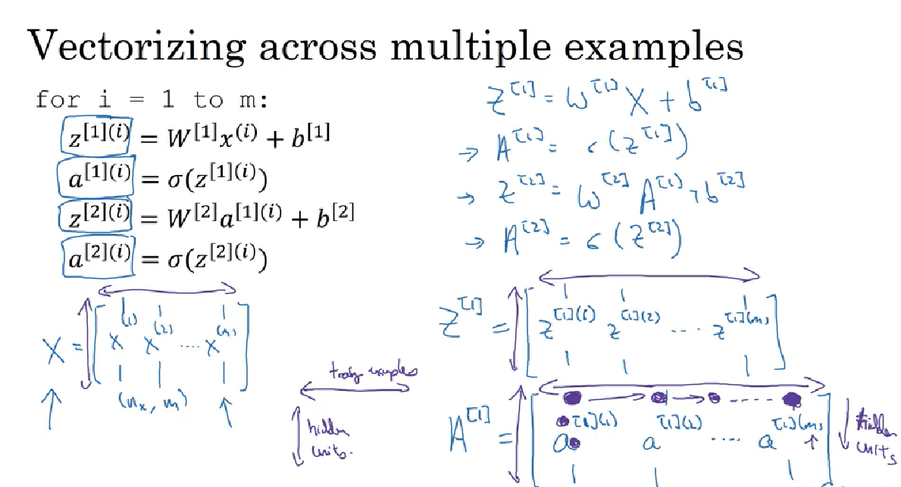

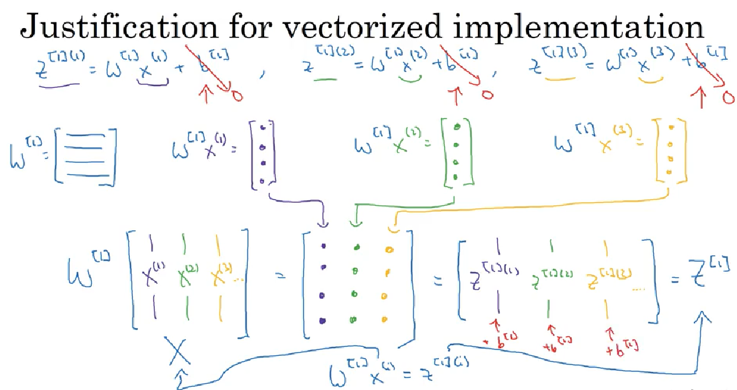

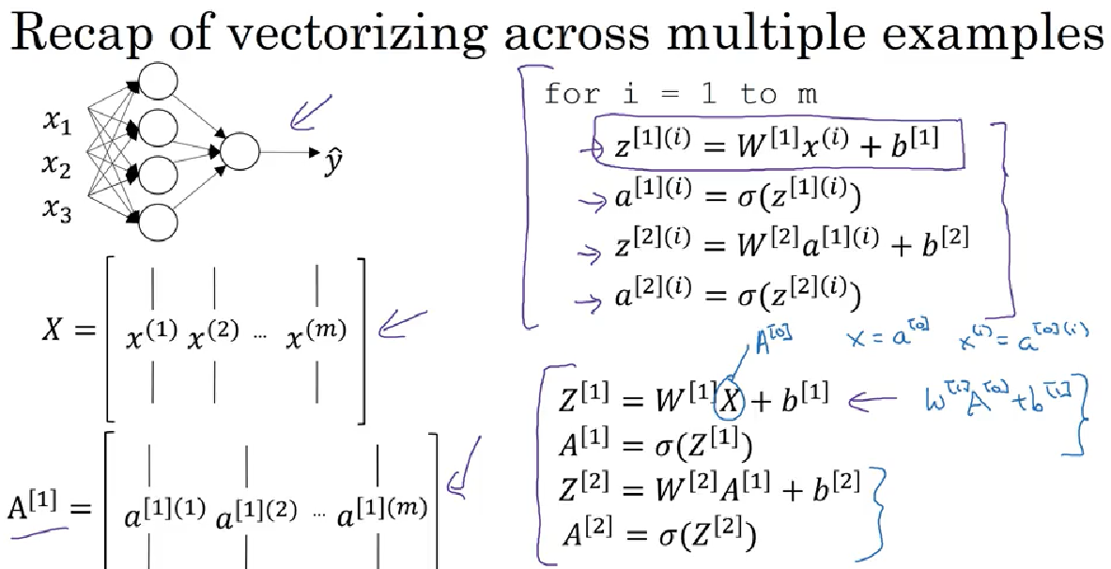

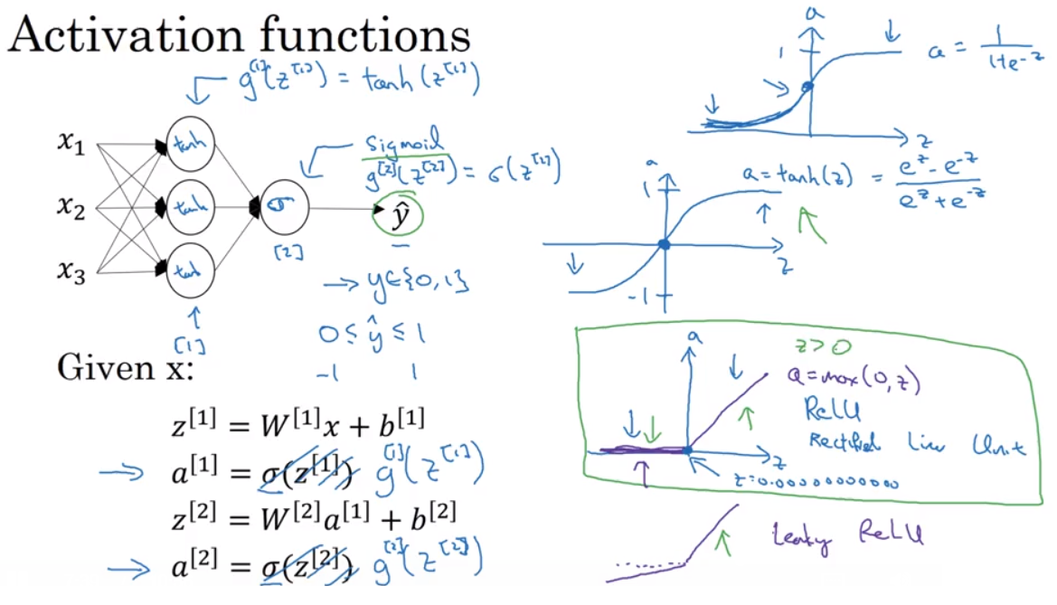

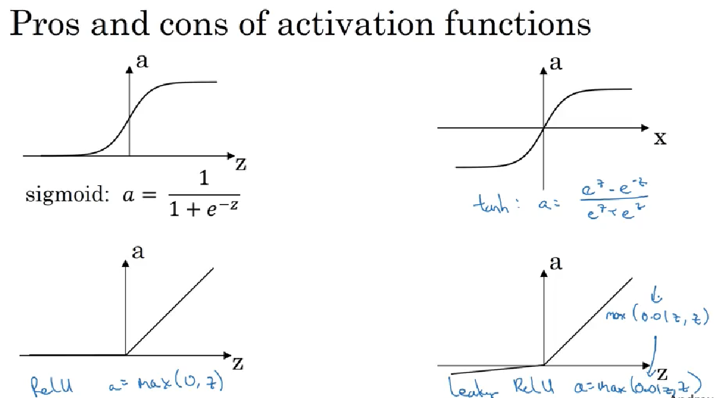

Sigma – never use this except output layer if you are doing binary, since tanh is superior. Most commonly used (default) activation function is ReLU and you may want to try Leaky ReLU

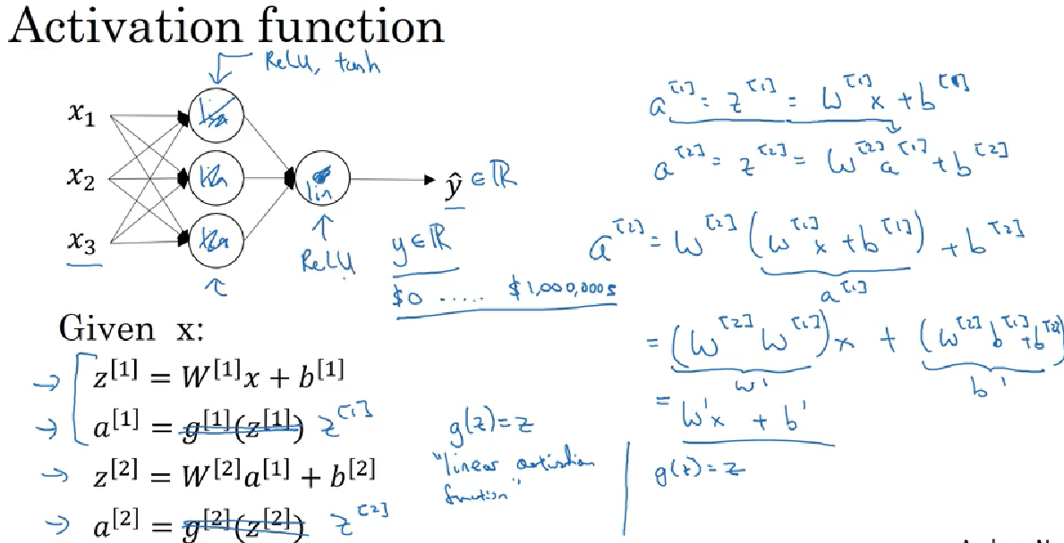

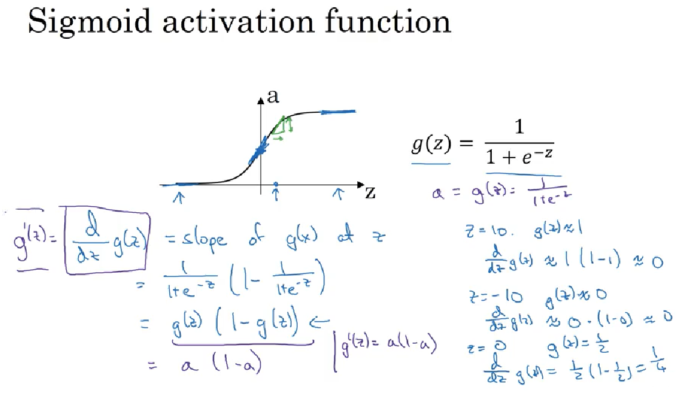

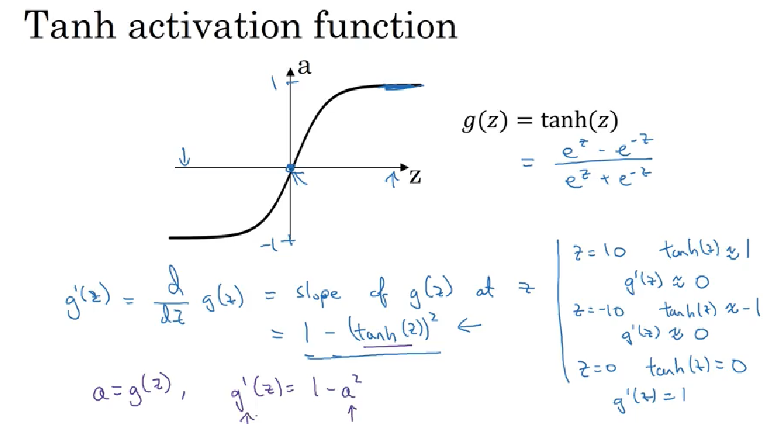

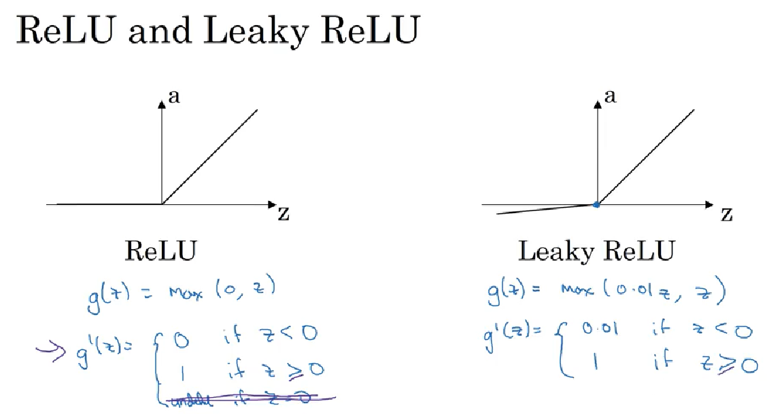

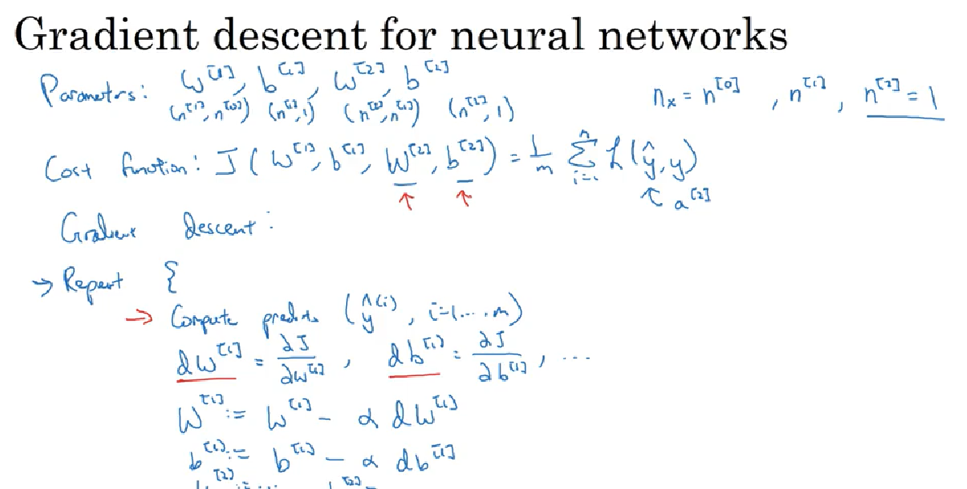

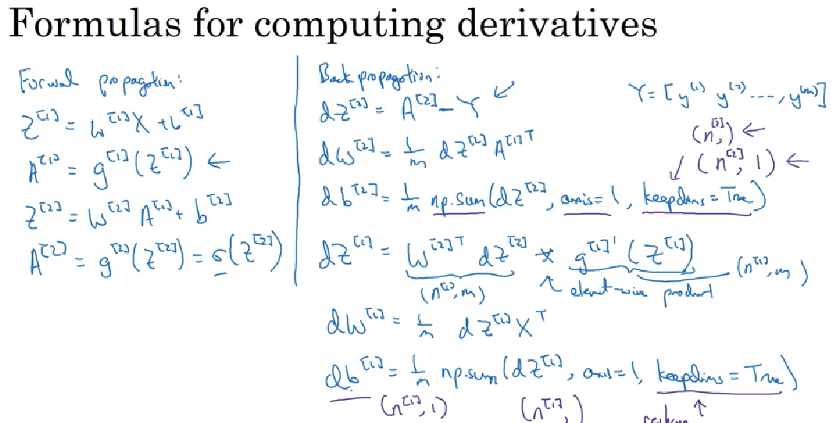

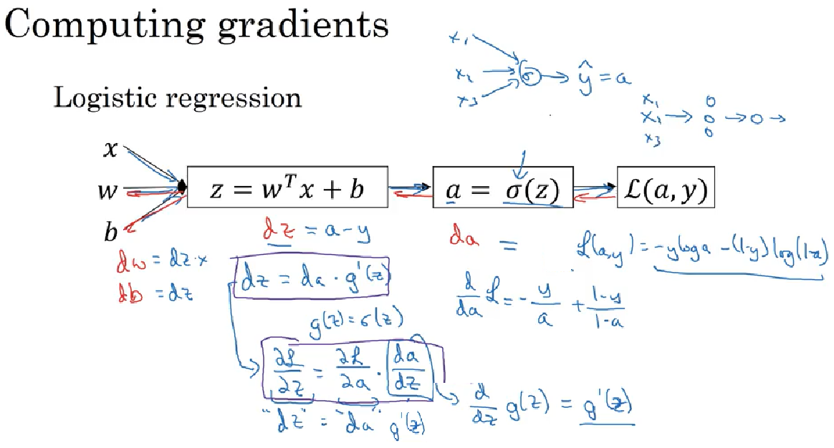

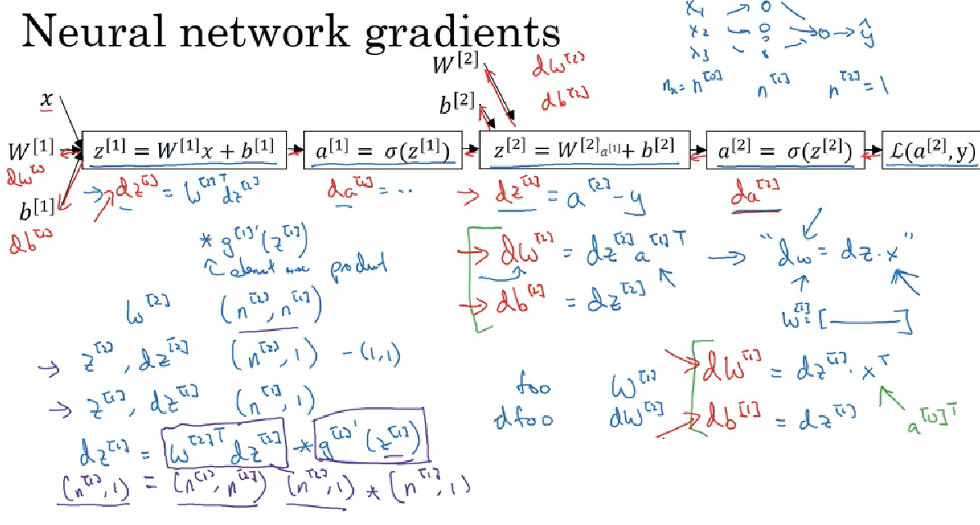

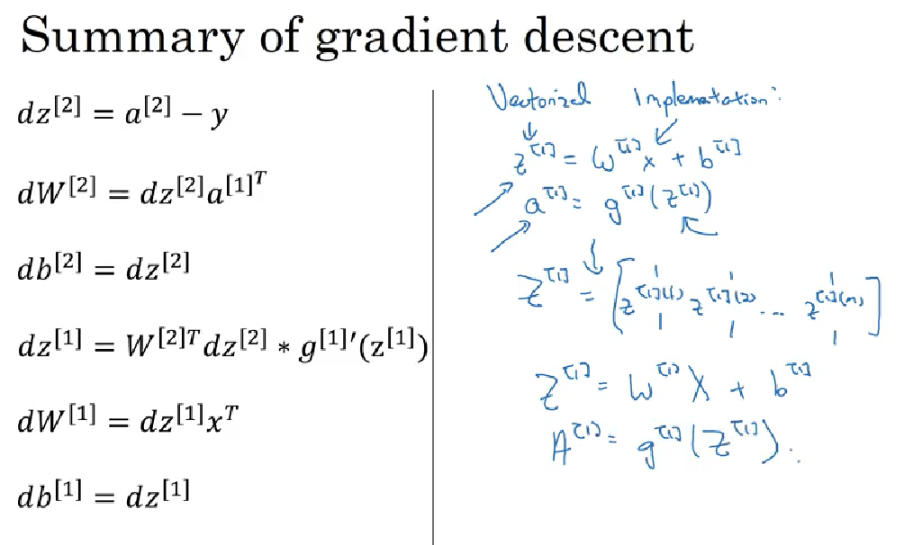

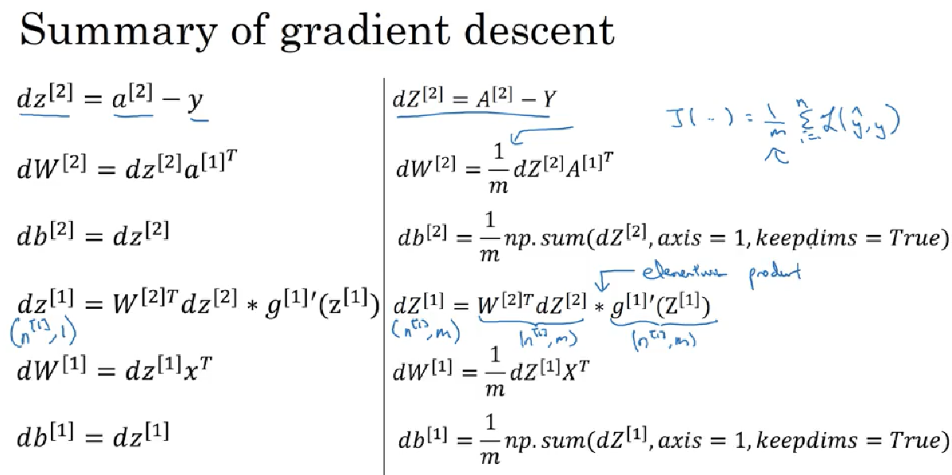

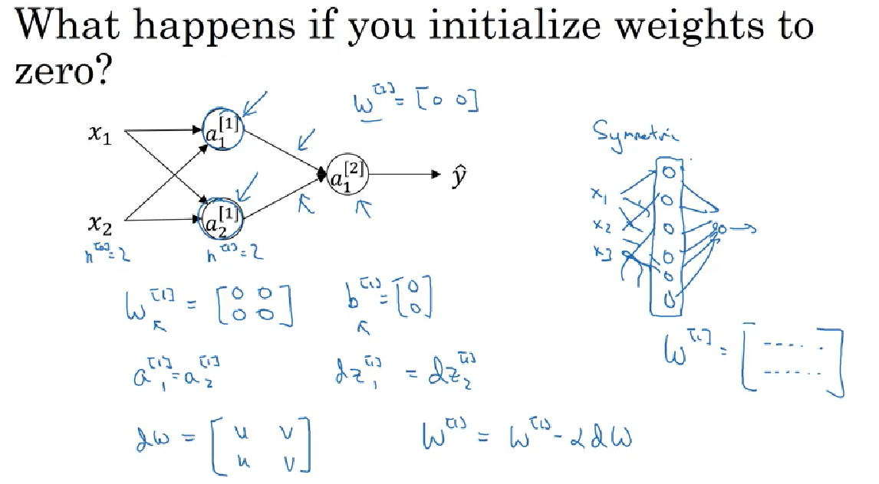

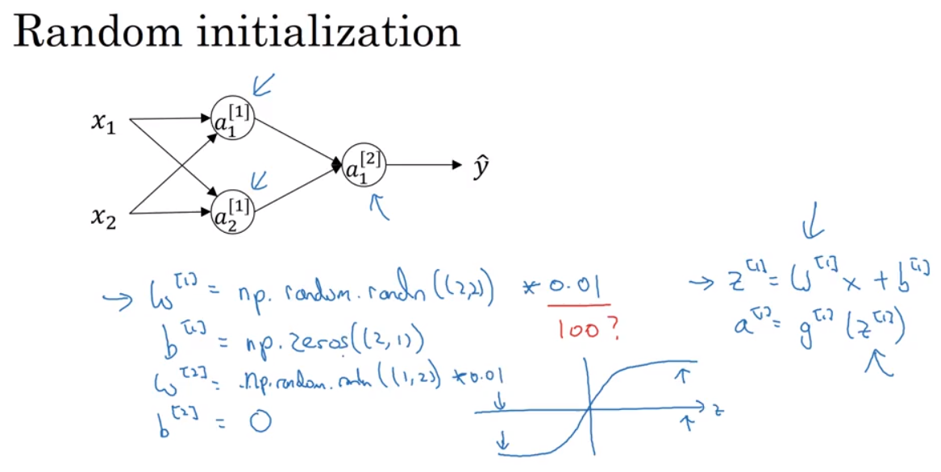

Week 4

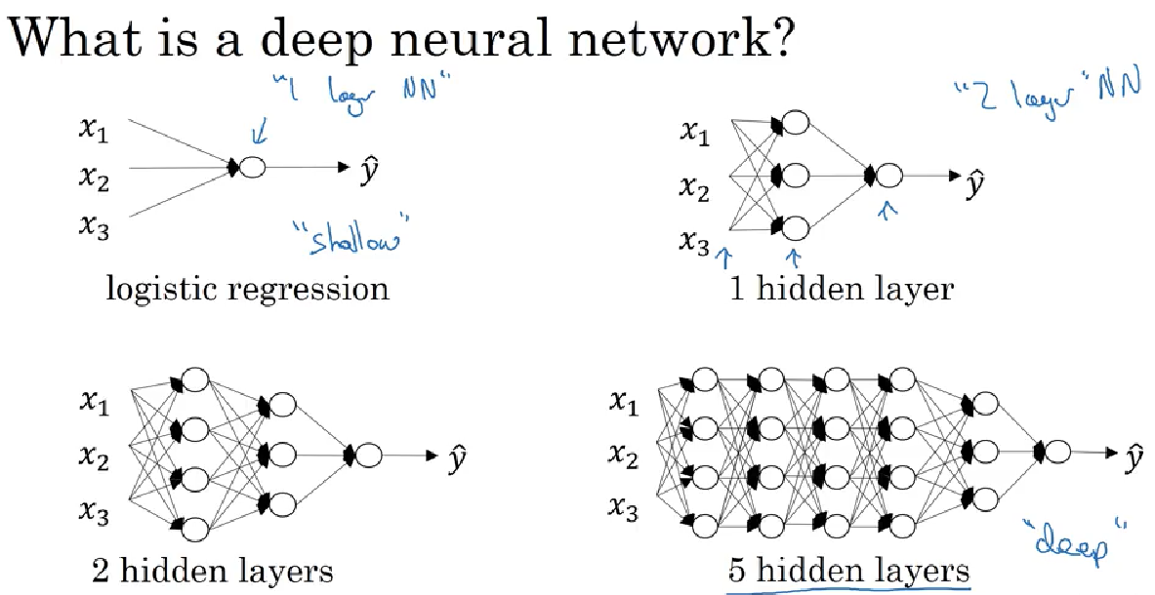

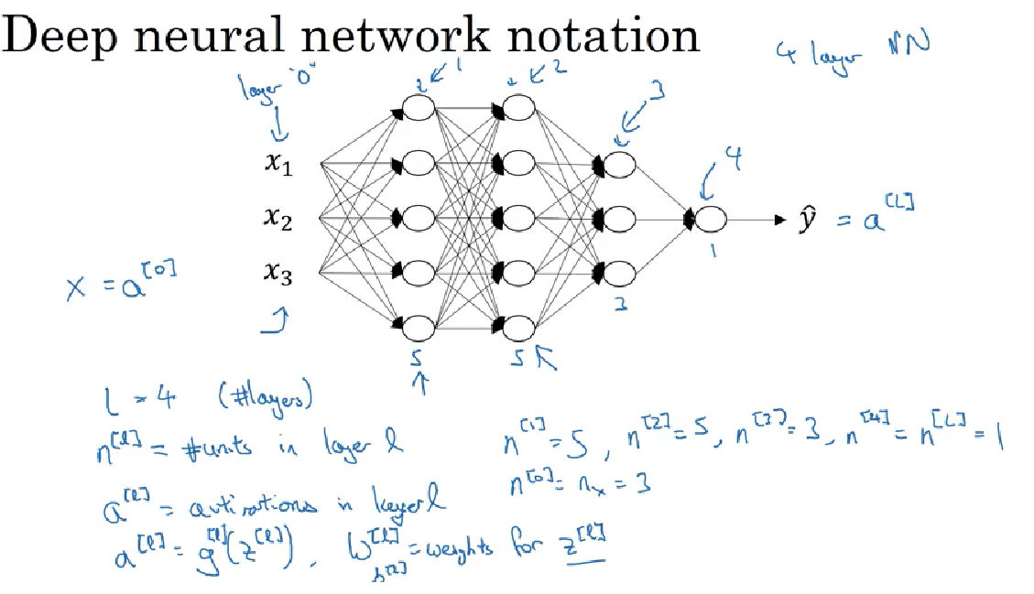

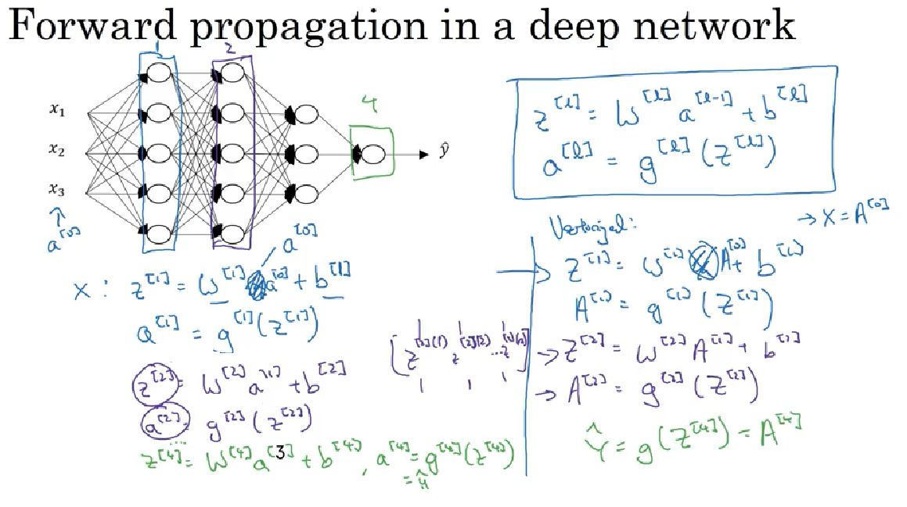

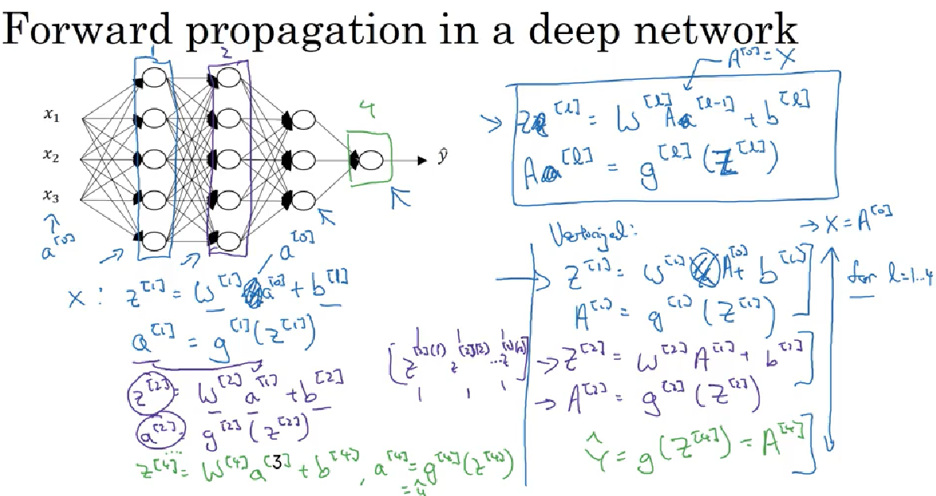

Explicit for loop is necessary to compute the activations in layers

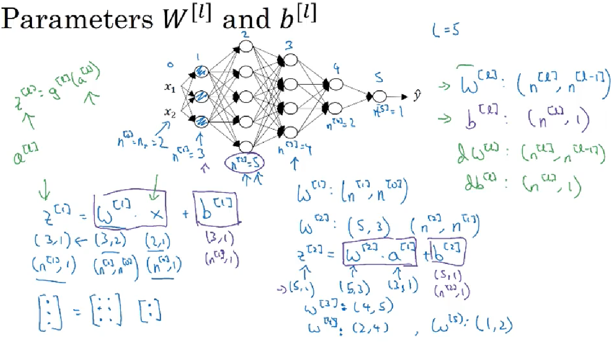

Dimensions… z[1] is (3,1) and x is (2,1). w[1] gets multiplied by x and the product is z[1]. So w[1] dimension has to be (3,2) as per matrix operation. As far as b[1] is concerned, it has to be the same as z[1] which is (3,1)

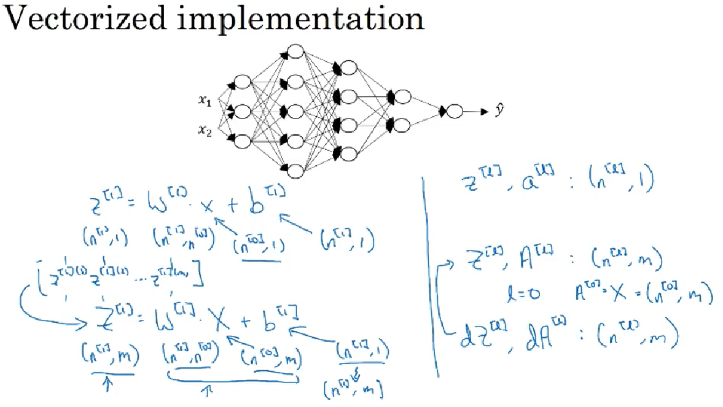

Note - b will broadcast in python , repeating m times so (n[1],1) will become (n[1],m)

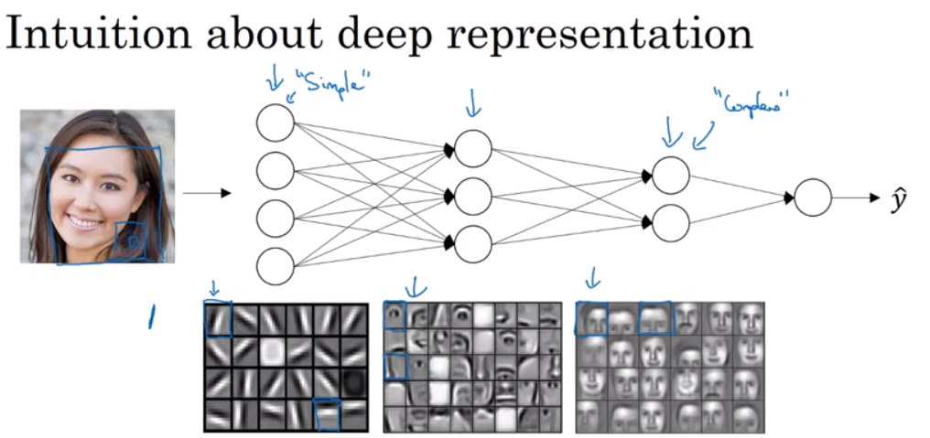

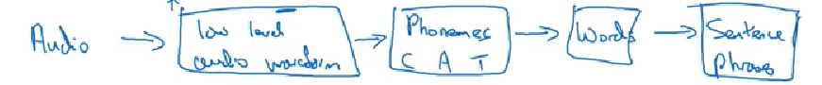

Low level simpler features, then deeper layer and compose whole object

